MANGOCHI CATHOLIC DIOCESE MOCK EXAMINATIONS
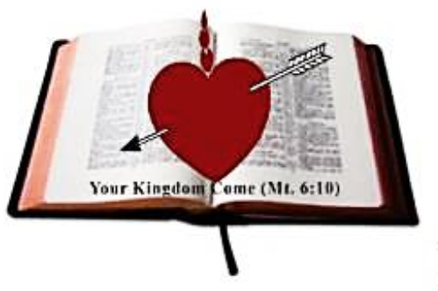
2025 MALAWI SCHOOL CERTIFICATE OF EDUCATION
GEOGRAPHY
Subject Number: M073/II
Thursday, 22 May 2025
Time Allowed: 2hrs
1:00 - 3:00 pm

PAPER II
(100 marks)
HUMAN AND ECONOMIC GEOGRAPHY
Instructions
Question number | Tick if answered | Do not write in these columns
1
2
3
4
5
- This paper contains 9 pages. Please check.
- The paper has five questions. Answer the questions in the spaces provided.
- There are two sections, A and B. Answer all the three questions in section A and any one question in Section B.
- The maximum number of marks for the answers is indicated against each question.
- Write your Examination Number on top of each page of the question paper.
- In the table provided on this page tick against the
number of question you have answered.

© 2025 MH DIOCESE Turn over

SECTION A (75 MARKS)
Answer all questions.
- a. (i). Give any two aims of World Trade Organisation.
________________________________________________________
________________________________________________ (2 marks)
(ii) State any two ways how World Trade Organisation (WTO) promotes
world trade.
_________________________________________________________
_________________________________________________________
_________________________________________________________
__________________________________________________(2 marks)
(iii) Give any two main roles of customs.
_________________________________________________________
__________________________________________________(2 marks)
b. (i) Give any one example of municipal wastes.
_________________________________________________________
_________________________________________________(2 marks)
(ii) State any two ways of disposing municipal wastes.
_________________________________________________________
_________________________________________________(2 marks)
c. Figure 1 is a map showing world shipping route in Africa. Use it to answer questions that follow.
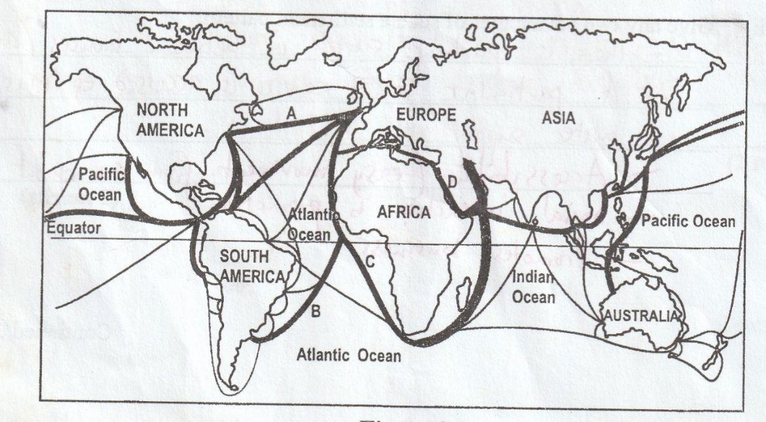

Figure 1

- Identify shipping routes A and B.
A: ____________________________________________(1 mark)
B: ____________________________________________(1 mark)

Continued/…
- State one advantage of using shipping route D over shipping route C to European states.
________________________________________________________________________________________________________________________ (2 marks)
- Give any two main goods transported through shipping route D.
________________________________________________________________________________________________________________________ (2 marks)
- Describe any one reason why the following regions have low railway connectivity.
1. Central Africa
________________________________________________________________________________________________________________________ (2 marks)
2. North Africa
________________________________________________________________________________________________________________________ (2 marks)
d. Figure 2 is a type of settlement pattern. Use it to answer questions that
follow:
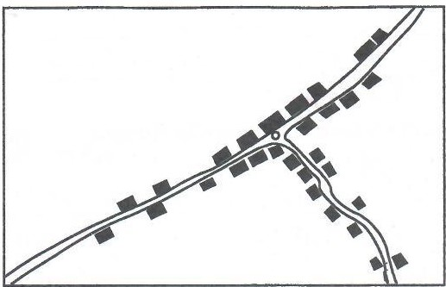

Figure 2
- Identify the settlement pattern.
_______________________________________________(1 marks)
- State two social features that promote development of the settlement pattern.
______________________________________________________
_______________________________________________(2 marks)

- Describe any two economic advantages of the settlement pattern in the figure.
_______________________________________________________
________________________________________________ (2 marks
2.a. (i) Give any two conditions in which petroleum is formed.
_________________________________________________________
_________________________________________________ (2 marks)
(ii) Describe how petroleum occurs in an anticlinal trap.
__________________________________________________(3 marks)

Continued/…
(iii) Explain how petroleum is refined using primary distillation.
____________________________________________________________________________________________________________________________________________________________________________________________________________________________________________________________________________________________________________________________________________________________________________________________ (5 marks)
b. Figure 3 is a diagram showing production of energy. Use it to answer questions that follow:
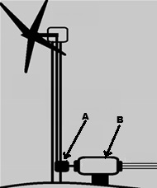
Figure 3
- Identify the energy being produced in the figure.
___________________________________________________ (1 mark)
- Name the parts labelled A and B.
A: _________________________________________________ (1 mark)
B: _________________________________________________ (1 mark)
- Explain how the energy being shown in the figure 3 is produced.
________________________________________________________________________________________________________________________________________________________________________________________________________________________________________________________________________________(5 marks)
- Give any two reasons why the energy being shown in figure 3 is scarce.
__________________________________________________________________________________________________________________________________________________________________________________________________________ (2 marks)

Continued/…
c. Figure 4 is a type of fishing net. Use it to answer questions that follow:
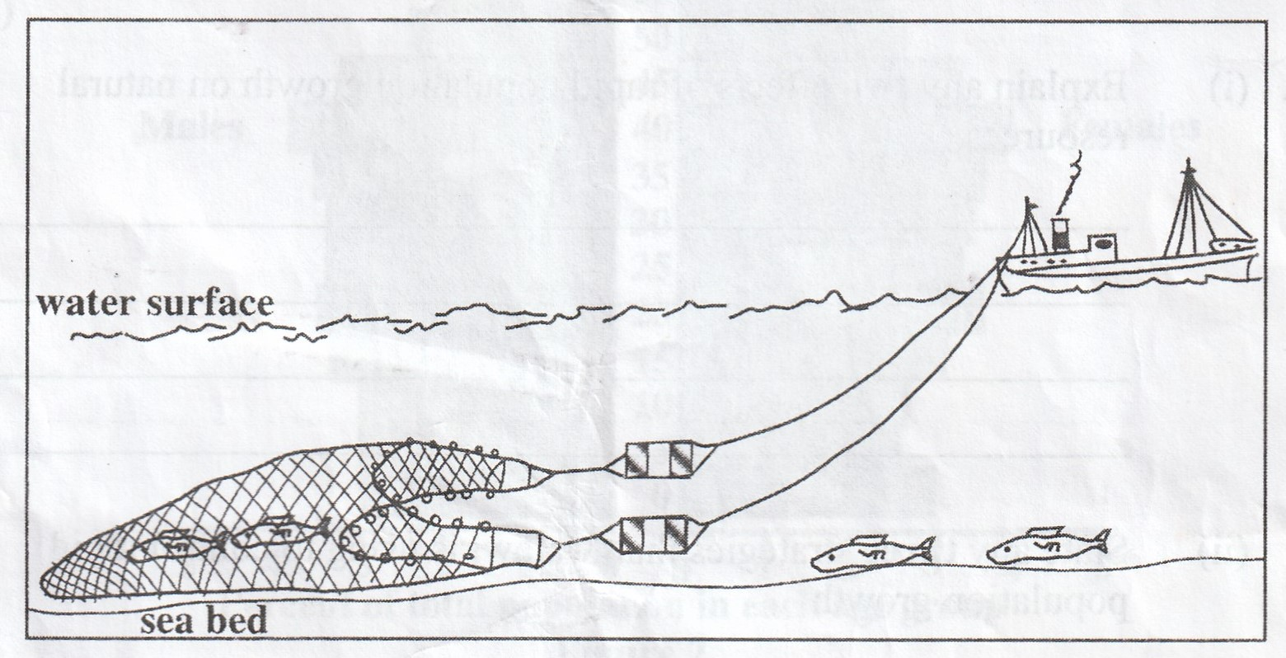
- Identify the fishing net.
___________________________________________________ (1 mark)
- Explain how the fishing net is used to catch fish.
______________________________________________________________________________________________________________________________________________________________________________________________________(3 marks)
- Name one fish caught by using the fishing net.
___________________________________________________(1 mark)

3. a. (i) Give any two international conventions on climate change.
____________________________________________________________
____________________________________________________(2 marks)
(ii)Explain any two social benefits of joining international conventions on
climate change.
____________________________________________________________
____________________________________________________________
____________________________________________________________
_____________________________________________________(4 marks)
(iii) State any two local ways of controlling climate change.
____________________________________________________________
____________________________________________________(2 marks)

Continued/…
b. (i) Mention any two rocks in which uranium occurs.
____________________________________________________________
_____________________________________________________(2 marks)

(ii) Give any two steps in the processing of uranium.
____________________________________________________________
____________________________________________________(2 marks)
(iii)State any two uses of uranium.
____________________________________________________________
____________________________________________________ (2 marks)
c.(i) Describe any two negative impacts of energy crisis.
____________________________________________________________
____________________________________________________________
____________________________________________________________
____________________________________________________(4 marks)
(ii)Give any two ways of reducing impacts of energy crisis.
____________________________________________________________
___________________________________________________ (2 marks)
d. (i) Mention any two countries that belong to North American industrial
region.
___________________________________________________________
____________________________________________________(2 marks)
(ii)Explain any two factors for growth of North Western Europe as a major
industrial area.
______________________________________________________________________________________________________________________________________________________________________________________________________________________________________________________________________________________________________________(4 marks)

Section B (25 marks)
Answer one question only from this section in the spaces provided.

- a. (i) Describe any two social factors that encourage irrigation farming.
_______________________________________________________________________________________________________________________________________(4 marks)
(ii)Give any two challenges faced when sourcing water for irrigation in Israel.
_______________________________________________________________________________________________________________________________________________________________________________________________________________________________________________________________________________________(2 marks)

Continued/…
b. Explain how the following factors encourage irrigation in Israel:
(i) nature of the soil
_____________________________________________________________
____________________________________________________ (2 marks)
(ii) climate
_____________________________________________________________
_____________________________________________________ (2 marks)
c. Figure 5 is a population pyramid. Use it to answer questions that
follow.
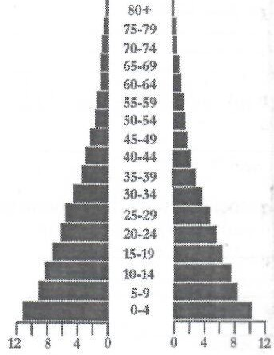

Figure 5
- Identify the type of population pyramid.
_____________________________________________ (1 mark)
- Using the figure, describe each of the following population elements of the country represented by the population pyramid:
- birth rate.
___________________________________________ (2 marks)
- life expectancy.
___________________________________________ (2 marks)
- State two positive implications to a country having a population structure represented by the population pyramid.
__________________________________________________________________________________________________________________________________________________________________________________________________________________________________________________(2 marks)

Continued/…
- Explain one reason why the Monsoon lands of Asia are highly populated.
______________________________________________(2 marks)
d. Explain why tea requires the following conditions for it to grow well:
(i) frost free conditions
_______________________________________________________
________________________________________________(2 marks)
(ii) plateau areas
_______________________________________________________
________________________________________________(2 marks)
e. Why is sifting in the processing of tea important?
__________________________________________________________
___________________________________________________(2 marks)
5.a. (i) Give any two reasons why lakes attract more tourists in Africa.
____________________________________________________________
____________________________________________________(2 marks)
(ii)Explain any two environmental problems caused by tourism in Africa.
____________________________________________________________
____________________________________________________________
____________________________________________________________
____________________________________________________(4 marks)
(iii)Mention any two eco- tourist centres in Malawi.
____________________________________________________________
____________________________________________________(2 marks)
(iv) State two ways in which local people benefit from eco-tourism.
____________________________________________________________
____________________________________________________(2 marks)

Continued/…
b. Figure 6 is map of the world showing world population densities. Use it to
answer questions that follow.
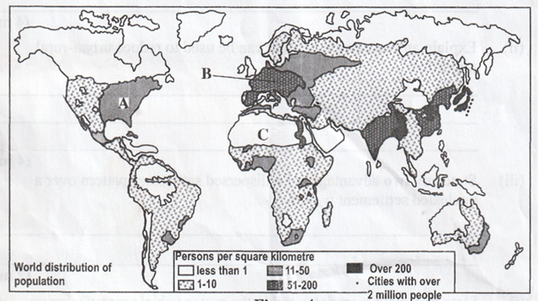
Figure 6
- Describe any two factors that have led to high population concentration in region A.
___________________________________________________________________________________________________________________________________________________________________________________________________________________________________________________________________________(4 marks)
- Why does region C have low population?
________________________________________________________________________________________________________________________________ (2 marks)
- Give any two countries that are found in region C.
_________________________________________________________________________________________________________________________________(2 marks)
- Describe the population size of region B.
_________________________________________________________________________________________________________________________________(2 marks)
- Give one reason for the population size of region B in 3b (iii) above.
__________________________________________________________________________________________________________________________________ (1 mark)
c.(i) Name any two examples of non-metallic minerals.
________________________________________________________________________
________________________________________________________________( 2 marks)
(ii) Explain one importance of minerals.
________________________________________________________________________
_______________________________________________________________ (2 marks)
END OF QUESTION PAPER
NB: This paper contains 9 printed pages

